Paper Title (15pt Arial, bold, center aligned)

N. G. Neer¹, and C. O. Author²

¹Title(s), Institution/Company/University, City, Country, email: imauthor@abcd.com
²Professor, Wonder University, Metropolis, Wonderland, email: co.author@wonder.edu.gr

Abstract
Abstract must be entered with 10pt Arial font and must be limited to one (1) paragraph of no more than 250 words. Avoid citations and equations in the abstract. Below the abstract include up to 6 keywords that best describe the focus of the paper.

Keywords: 10pt, Arial font, italics

INTRODUCTION
The authors of the papers should prepare their contributions in accordance with the layout instructions. To ensure a uniform layout, the authors are encouraged to assemble their paper using the provided template. This template is also available on the Congress website https://tc301-athens.com/.

paper layout

Length of the paper and publication details
The proceedings will be published in digital format only. The recommended paper length: 6-8 pages. Submitted papers shall not exceed the maximum size of 8 MB. Do not number pages. The paper ID should appear at the header of the first page.

Structure of the paper
Please adhere to the following order of presentation:
Title
Author(s), Affiliation(s)
Abstract
Keywords
Main text
Acknowledgements (optional)
References
Text
Text should be written in one column. The first line of a paragraph should not be indented. Please use only metric units in the text. Type primary headings in capital letters (12pt, Arial, bold) and secondary and tertiary headings (11pt & 10pt, Arial) with only the first letter of the heading in capital, as shown in Table 1. Headings should not be indented. Do not use a full stop after the heading. Paragraphs should be separated with a one-line space. Do not number headings.
In the text, reference can be made to equations (1), tables (Table 1), figures (Figure 1), and literature quotes (King, 1998; Swifte & Smith, 2008a, b). Do not use bold font when referencing tables and figures. When the researcher’s name is embedded in the sentence, the reference does not need to be repeated at the end of that sentence. For example: Smith (2010) finds evidence that… should be used instead of: Smith (2010) finds evidence that… (Smith, 2010).

Effort should be made so that figures and tables be placed close to the text where the reference is made. All figures and tables must be referred to and described in the text.

Table 1. Layout of the proceedings. Table caption written in 10pt Arial text, italic, justify aligned

Layout | Font | Font Size | Font  Style | Line Spacing | Alignment | Notes
Title | Arial | 15pt | bold | single | centered
Authors names | Arial | 10pt | standard | single | centered
Authors affiliation | Arial | 8pt | italic | single | centered
Keywords | Arial | 10pt | italic | single | left
HEADING-1 | Arial | 12pt | bold | single | justify | capital letters
Heading-2 | Arial | 11pt | bold | single | justify | capital letter only for the first letter of the title
Heading-3 | Arial | 10pt | italic | single | justify | capital letter only for the first letter of the title
Body text-1 | Arial | 10pt | standard | single | justify
Figure | Arial | 10pt | italic | single | justify | located at the bottom of the figure
Caption of referencesª | Arial | 8pt | standard | single | justify
References | Arial | 9pt | standard | single | justify | spacing after: 4pt before: 0pt
ª Table footnotes should be entered in superscript letters. Write tables footnotes in Arial font size 8pt, standard and single line spacing with left alignment.

Paper size
Use A4 page size (21.0 cm / 29.7 cm) with the margins set at 2.5 cm (0.1 inches) top and bottom and 2.5 cm (0.1 inches) left and right. Please format without any page number or footer.

Equations
Equations should be preceded and followed by a one-line space. An example of an equation and equation numbering format follows:

V/V_{w} = 0.731n² – 1.33n + 1.59 (1)

where V, V_{w}, and n are variables in the equation and should be described in the text.

Figures and tables

Recommendations for preparing figures and tables
Figures and tables should be included within the body of the paper. Table captions should be written above the table, as in Table 1, while figure captions should be written below the figure, as in Figure 1. The words Table and Figure with their associated numbering should be in bold and end with a full stop in the caption (see Table 1 and Figure 1). Authors are advised to comply with the provided table format (Table 1) and figure format (Figure 1). Leave a one-line space between the main text and table or figure (before and after).

Figures and tables shall be numbered consecutively in the order in which reference is made to them, making no distinction between charts and photographs. The most convenient place for placing figures is at the top or bottom of a page.

Arrangement of figures in the text
Keep figures as simple as possible and avoid excessive notes. To assist formatting, authors are kindly asked to place the figure within a 2-row, 1-column table with no-borders (see Figure 1). The figure will cover the top row with central alignment followed by the figure caption within the bottom row of the table with left alignment. It is allowed to place 2 figures side by side by introducing a second column in the table (see Figure 2).

Please ensure that all figures should be of the highest possible quality. Photographs must be scanned at 300 dpi. It is not advisable to use scanned charts.

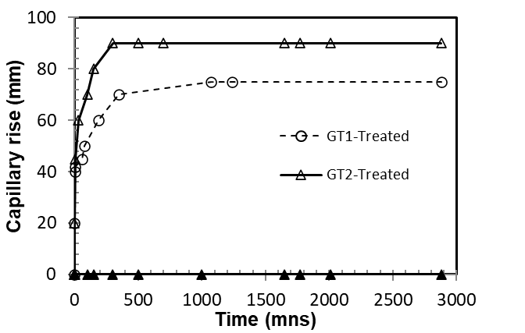

Figure 1. Figure caption written in 10pt Arial text, italic, justify aligned

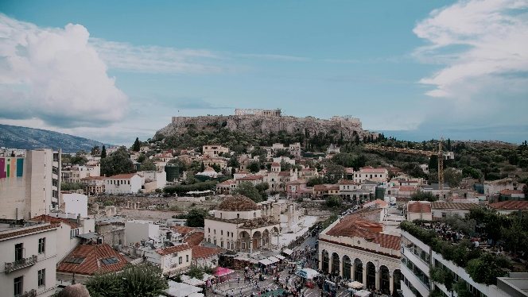 | 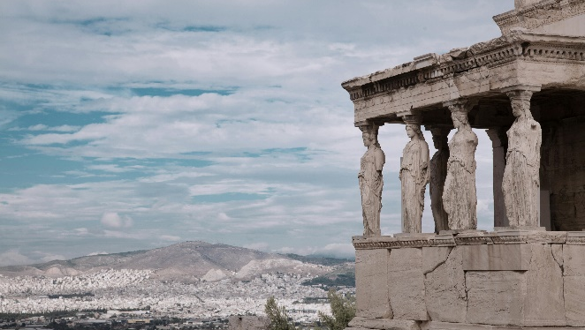
Figure 2. Description for the left side (left). Description for the right side (right)

Arrangement of tables in the text
Tables can run over more than one page. If they do so in your paper, please ensure that the table number and “(continued)” appear at the top of each new page on which the table continues.

If you have a particularly wide table, please do not change the orientation of the page from portrait to landscape. Instead, create the table with its top row parallel with the left margin and its bottom row parallel with the right margin of the page.

GUIDELINES ON REFERENCES
References should be listed in the reference list at the end of the paper, which should be in alphabetical order. References will be written in 9pt Arial style with single line spacing and a 4pt after spacing. For consistency, full references should appear in APA 6th Edition referencing style. References are not allowed to appear in footnotes.

In-text references should include the name of the referenced author or authors and the year of publishing, for example: (Douglas, 2021) or (Collins & Name7, 1998). When citing publications with three or more authors use the first author’s surname followed by “et al.”, for example: (Abbott et al., 2010). When there are several references to be cited at one place, order them from earliest to latest and separate them with a semi-column (;), for example: (Beacher, 2011; Douglas, 2021). If several works by the same author are cited, entries should be chronological, and if there is more than one reference of the same year, you should add a, b, etc. in the in-text reference and corresponding reference list, for example: (Patten, 1973b).

CONCLUSIONS
The conclusions are a vital part of the paper and should state concisely the most important outcomes as well as the author’s views of the practical implications of the results. Papers without conclusions will be considered complete.

ACKNOWLEDGEMENTS

REFERENCES
Abbott, A. B., Name2, C. D., Name3, E., & Name4, F. (2010). Settlement analysis of municipal solid waste. Journal of Environmental Engineering, 130(8), 1272-1279.
Beacher, F. G. (2011). Remediation of arsenic-contaminated soils. In H. I. Bowders, & J. Smith (Ed.), International Conference on Soil Remediation, (pp. 152-167). Cardiff, U.K.
Collins, K., & Name7, M. (1998). Waste Containment Facilities. Melbourne: CRC Press.
Douglas, N. (2021). Review of remediation techniques. Retrieved October 2, 2022, from ABCD: http://www.abcd.com

